Max Bender

Lab 2

Not Dragon

3.3

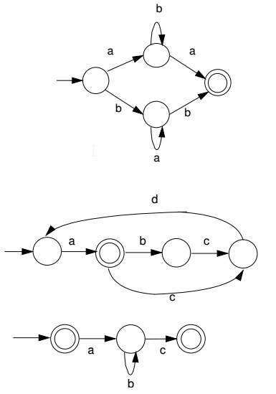

(ab\*a|ba\*b)

(a (bcda)\* (cda)\*)

(a? b\* c)